**Worksheet-2.2**

**Student Name:- Pushpraj Roy UID:- 20BCS9866**

**Branch:- BE- CSE Section/Group:- WM_617 “A”**

**Subjetct Code:- 20CSP-321 Semester:- 5th**

**Subject Name:- PBLJ Lab**

1. **Aim/ Overview of the practical:-**

Collect Unique Symbols From Set of Cards

1. **Task To be done :-**

Playing cards during travel is a fun filled experience. For this game they wanted to collect all four

unique symbols. Can you help these guys to collect unique symbols from a set of cards?

Create Card class with attributes symbol and number. From our main method collect each card

details (symbol and number) from the user.

Collect all these cards in a set, since set is used to store unique values or objects.

Once we collect all four different symbols display the first occurrence of card details in alphabetical order.

1. **S/W Requirements:-**

* JDK
* VS Code

1. **Code :-**

import java.util.*;

public class Main {

public static void main(String[] args){

Scanner input = new Scanner(System.in);

List<Integer> cardValue = new ArrayList<Integer>();

HashMap<String, List<Integer>> mp = new HashMap<>();

HashMap<String, Integer> firstEntry = new HashMap<>();

int totalNoOfCards, value;

System.out.println("\nEnter Number Of Cards : ");

totalNoOfCards = input.nextInt();

String cardType;

for(int index = 1; index <= totalNoOfCards; index++){

System.out.print("\nEnter Card Type of Card " + index + " : ");

cardType = input.next();

System.out.print("Enter Value of Card " + index + " : ");

value = input.nextInt();

if(mp.containsKey(cardType)){

if(cardValue.contains(value)){

System.out.println("No same card type have same value.\nProcess terminated.");

System.exit(0);

}

cardValue = mp.get(cardType);

cardValue.add(value);

}

else{

cardValue = new ArrayList<Integer>();

firstEntry.put(cardType,value);

cardValue.add(value);

mp.put(cardType, cardValue);

}

}

System.out.println();

int noOfSameCard=0,sumOfSameCard=0;

for(Map.Entry getData : mp.entrySet()){

System.out.println("\nCards with '" + getData.getKey() + "' Symbol : ");

ArrayList<Integer> symbolArray = (ArrayList<Integer>)

getData.getValue();

Iterator itr= symbolArray.iterator();

while(itr.hasNext()){

noOfSameCard++;

int num = (int) itr.next();

sumOfSameCard += num;

}

System.out.println("Number of Cards : " + noOfSameCard);

System.out.println("Sum of Values of Card Type '"+getData.getKey()+"' is: "+ sumOfSameCard);

sumOfSameCard = 0;

noOfSameCard = 0;

}

System.out.println("");

System.out.println("First Entry of Each Card Type.");

for(Map.Entry getData : firstEntry.entrySet()){

System.out.println(getData.getKey() + " -> "+getData.getValue());

}

}

}

1. **Result/Output/Writing Summary:-**

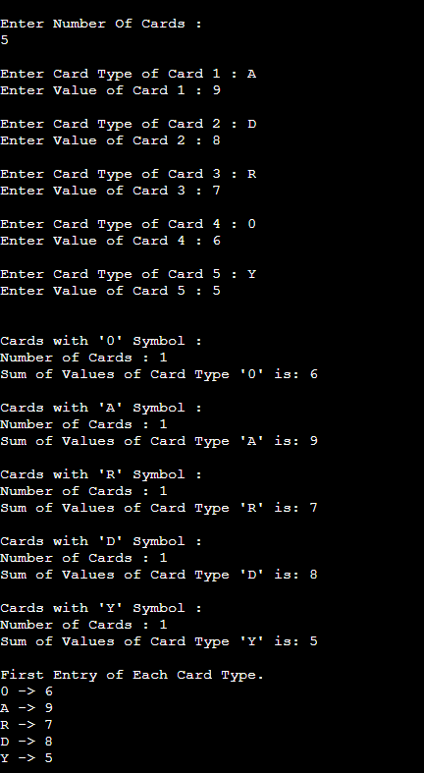

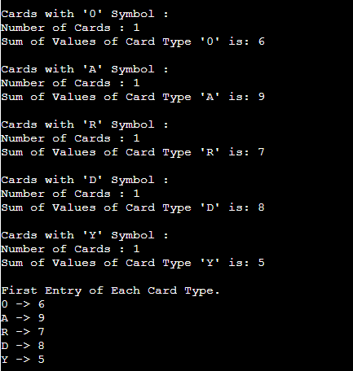

1. **Learning Outcomes (What I have learnt) :-**

* Learnt about maps.
* Got an overview of the maps and hashing.
* Get to know about crucial test cases.
* Got an understanding about referencing of maps.